

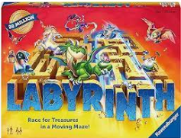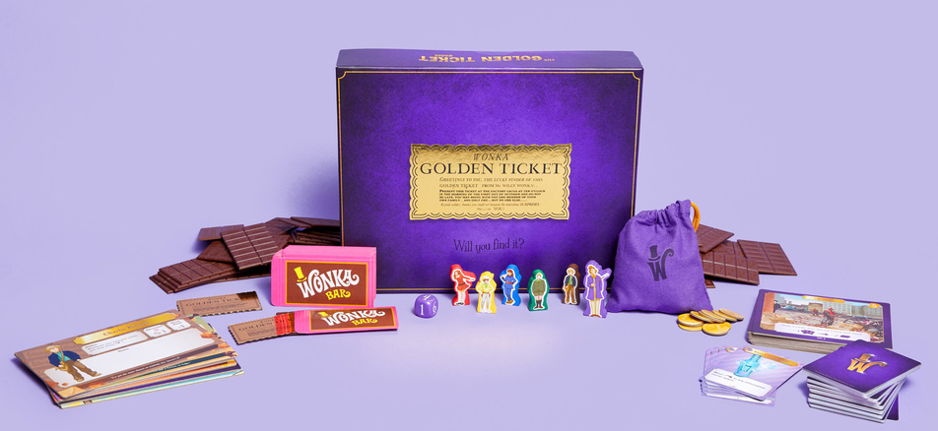  
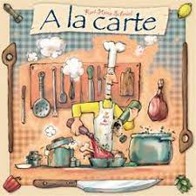

 **Join us in the Library Activity Room for   
Fun with Games & Puzzle Exchange!  
  
Games scheduled include: Labyrinth,   
A la Carte, NY Pizza Slice & Willy Wonka’s Golden Ticket!**

**Registration is not required but recommended for game play. Register in person or by calling 734-782-2430**

***Puzzle Exchange!***  ***Exchange is simple! Bring a gently used (no missing pieces) puzzle of varying size and trade it for one of similar size.  
There are currently a limited number of puzzles available. If you would like to donate a puzzle or drop one off earlier in the week you are welcome to do so. Donations will be gladly accepted and we can provide a voucher if you would like to return Saturday for a “NEW” puzzle!***

SATURDAY MORNING GAME DAY  
&  
PUZZLE EXCHANGE

**Saturday February 10th   
10:00 a.m. – 2:00 p.m.**